**EXPERIMENT NO:-7**

**Name : Rajashri Jaywant Patil**

**Title:-Creating Index and Views.**

**Index:**

**1] Show Database :**

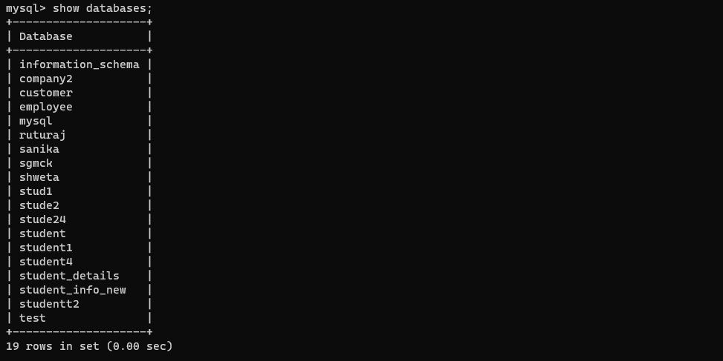

**2] Use Database :**



**3] Show Table :**

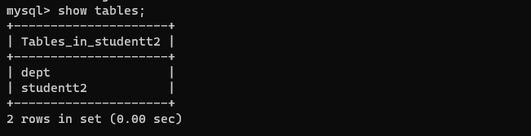

**4] Show Table :**

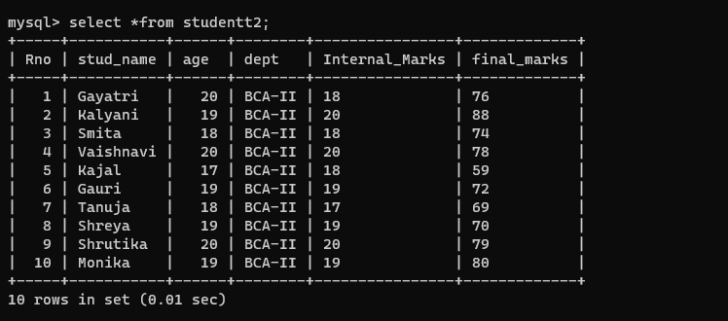

**5] Create Index :**

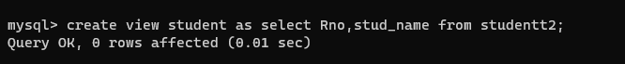

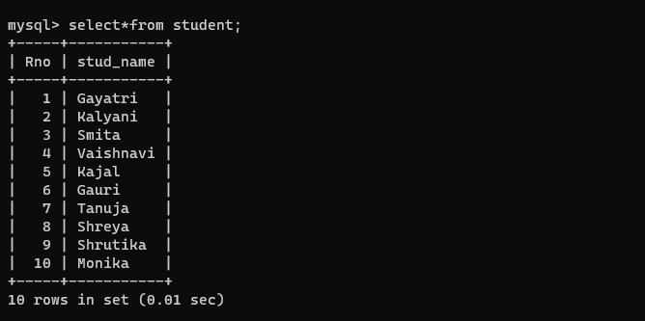

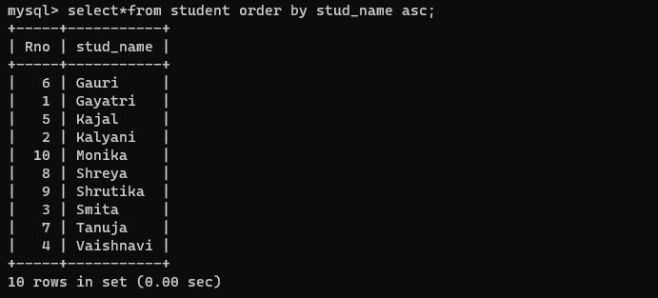



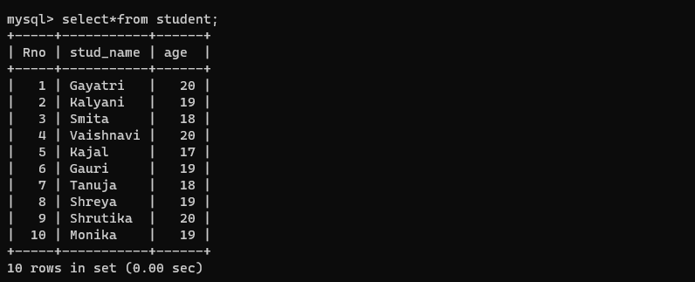

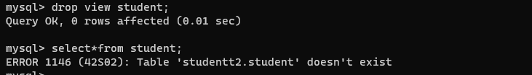

**Indexes:-**

